Evaluation: Random Forest
Accuracy: 0.97
Precision: 0.9700377001768222
Recall: 0.97
F1 Score: 0.9699809455239385
Jaccard Index: 0.9420349939813354
Matthews CorrCoef: 0.9625186730433872
Cohen’s Kappa: 0.9625
Specificity: 0.9925
AUC: 0.998922
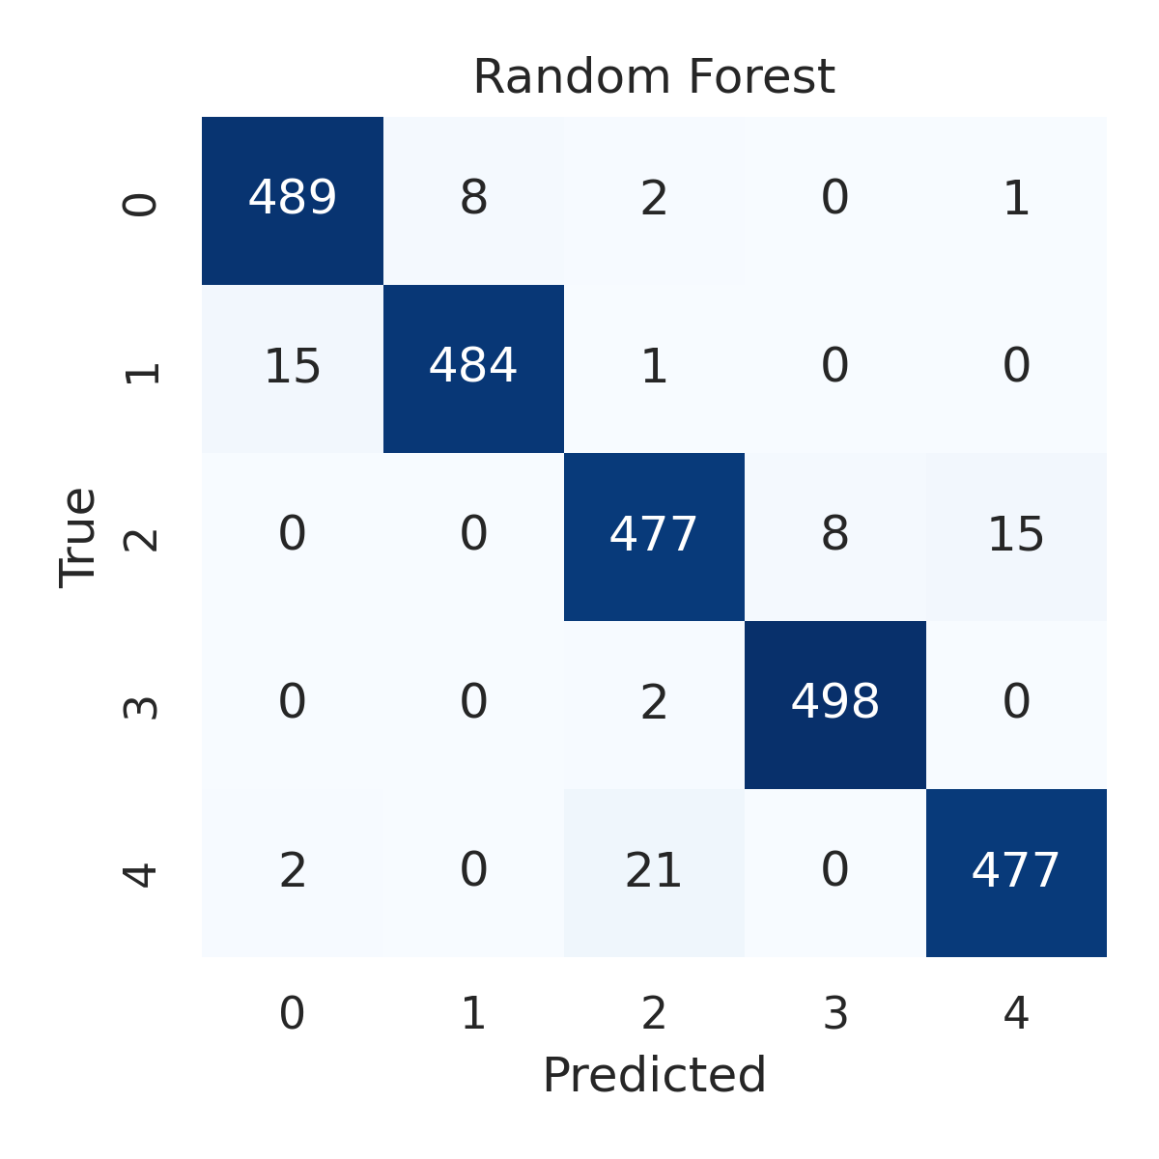

Combined ROC Curves
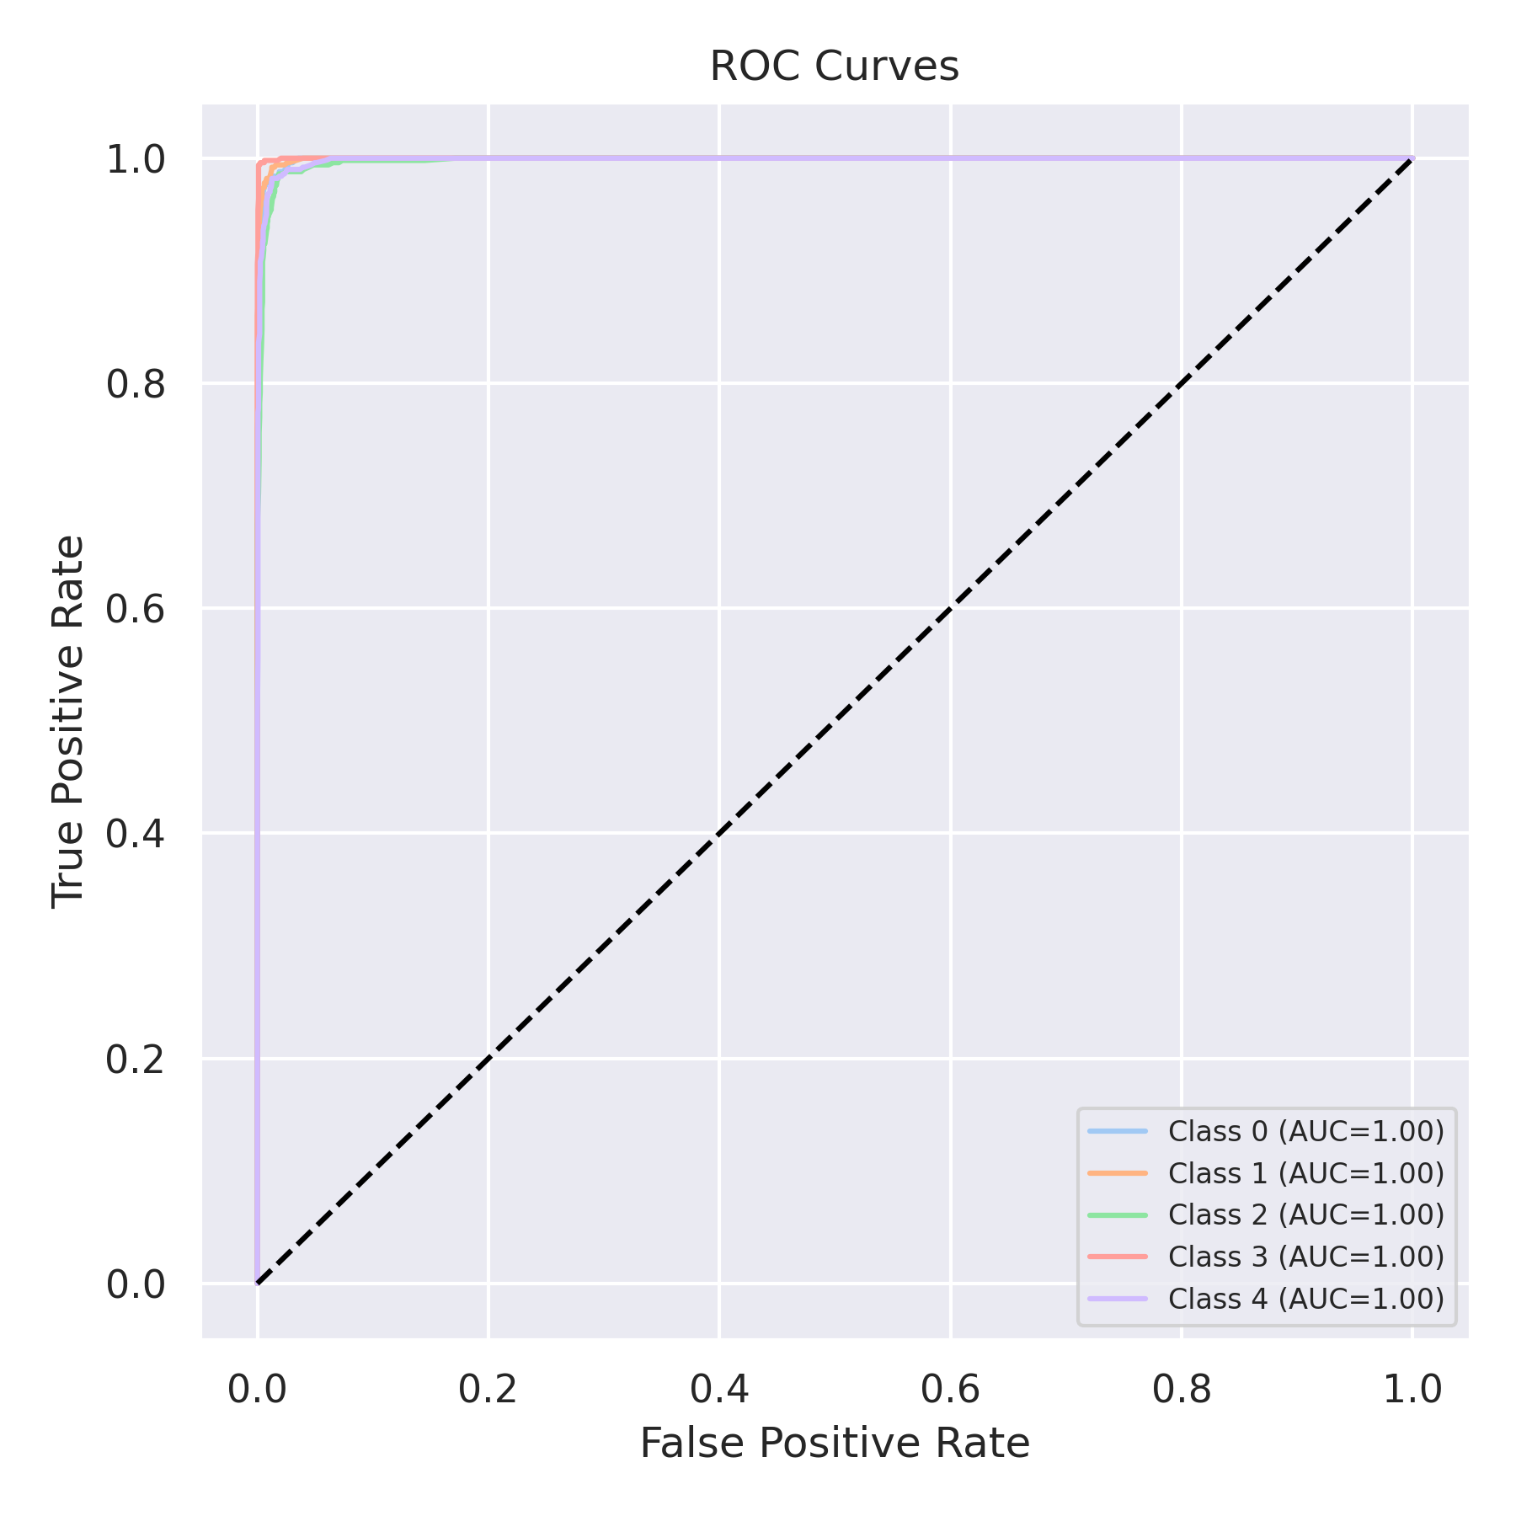

Evaluation: K-Nearest Neighbors
Accuracy: 0.9016
Precision: 0.9031674659174882
Recall: 0.9016
F1 Score: 0.9009369391754326
Jaccard Index: 0.821092830042077
Matthews CorrCoef: 0.8776933004532048
Cohen’s Kappa: 0.877
Specificity: 0.9754000000000002
AUC: 0.9812966
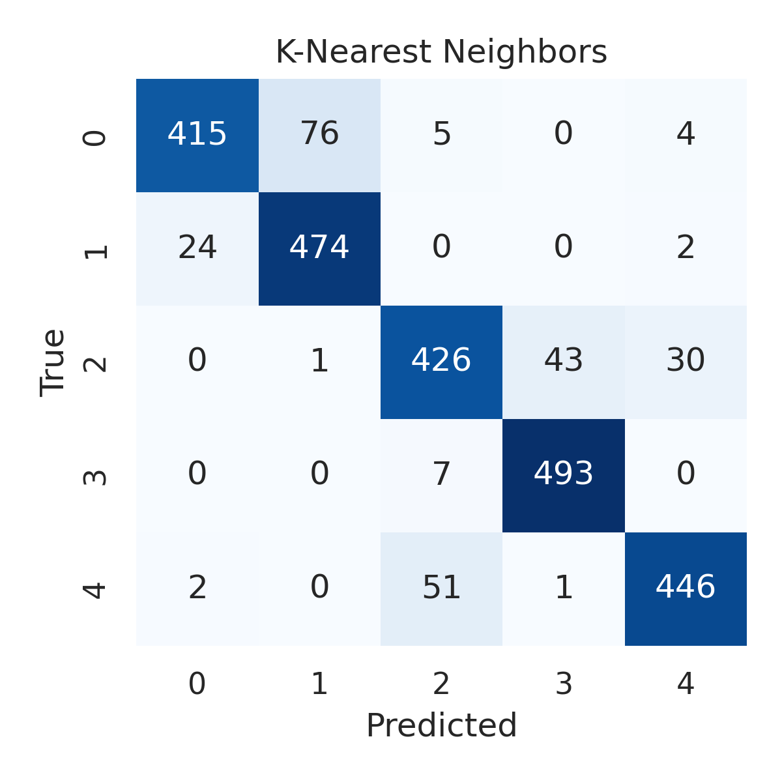

Combined ROC Curves
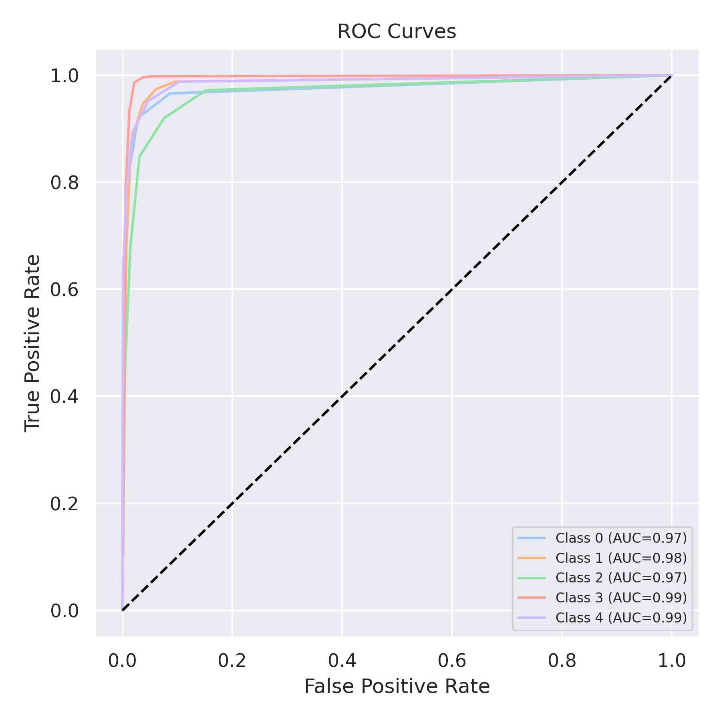

Evaluation: Decision Tree
Accuracy: 0.9628
Precision: 0.9628322187799299
Recall: 0.9628
F1 Score: 0.9627819546530249
Jaccard Index: 0.9287795194199809
Matthews CorrCoef: 0.9535169727531738
Cohen’s Kappa: 0.9535
Specificity: 0.9907
AUC: 0.97675
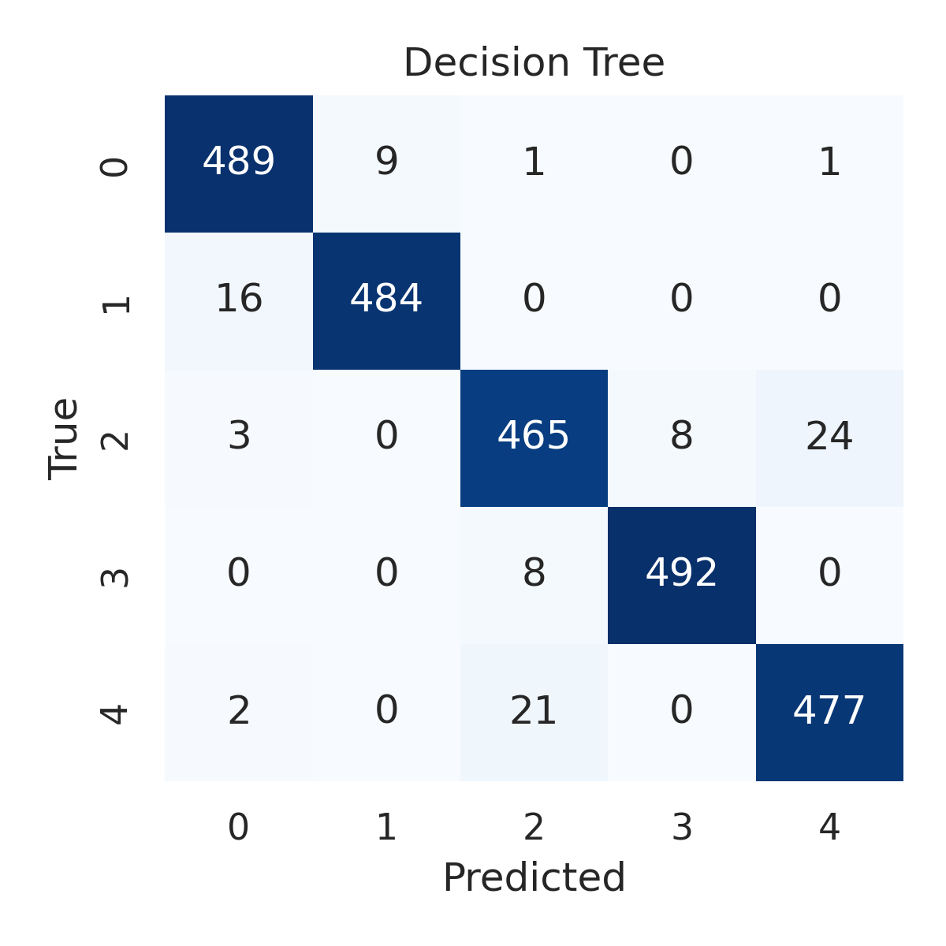

Combined ROC Curves
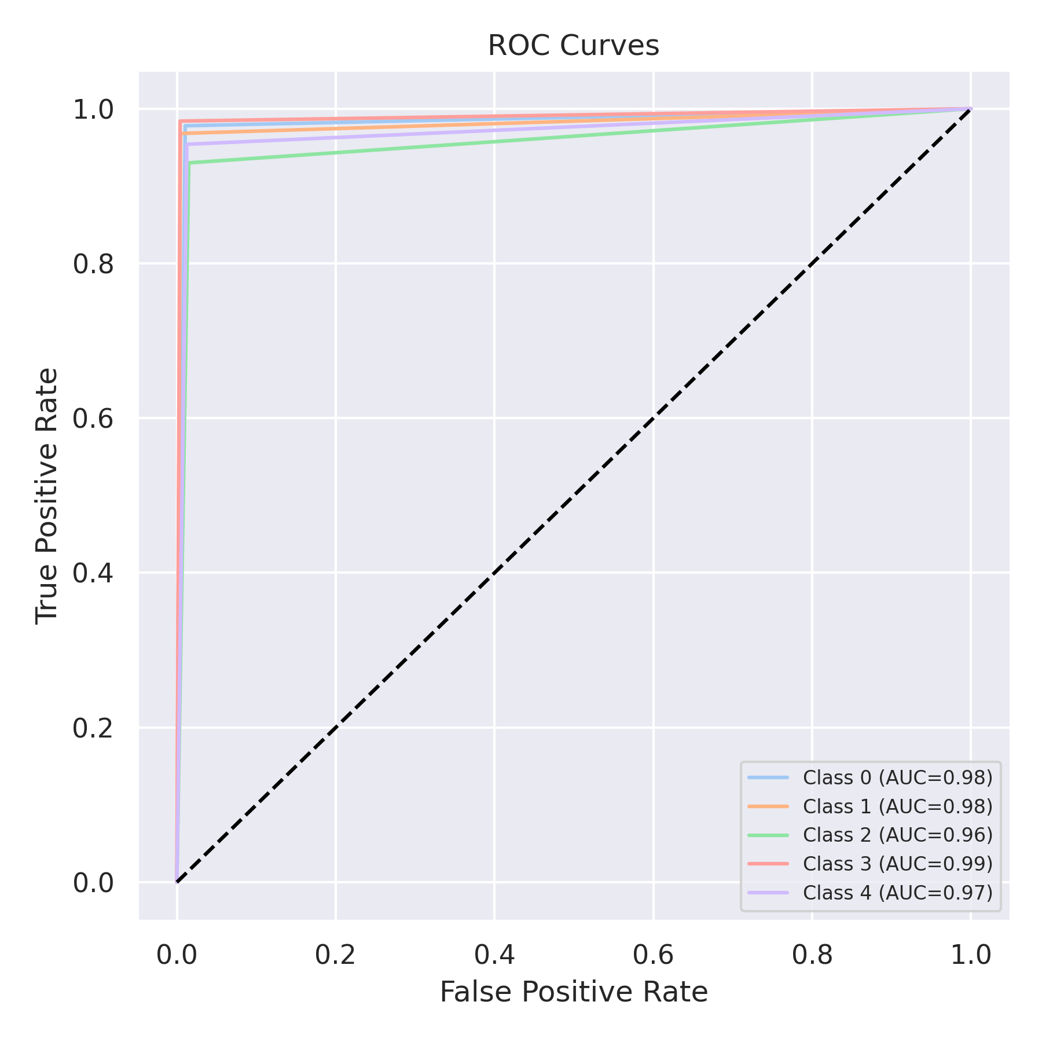

Evaluation: Extra Trees
Accuracy: 0.9724
Precision: 0.9724667896300739
Recall: 0.9724
F1 Score: 0.9723733792597532
Jaccard Index: 0.9464004984601819
Matthews CorrCoef: 0.9655295456561525
Cohen’s Kappa: 0.9655
Specificity: 0.9931000000000001
AUC: 0.9989861
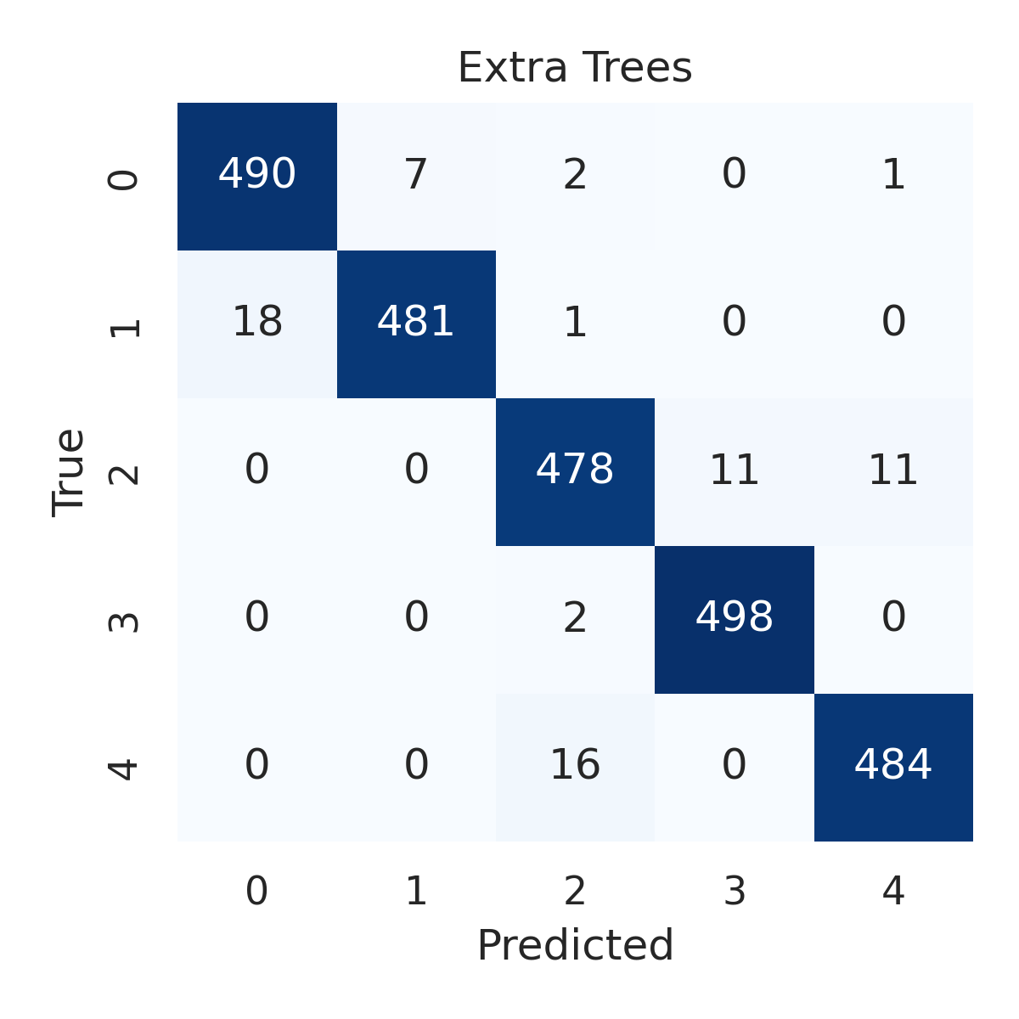

Combined ROC Curves
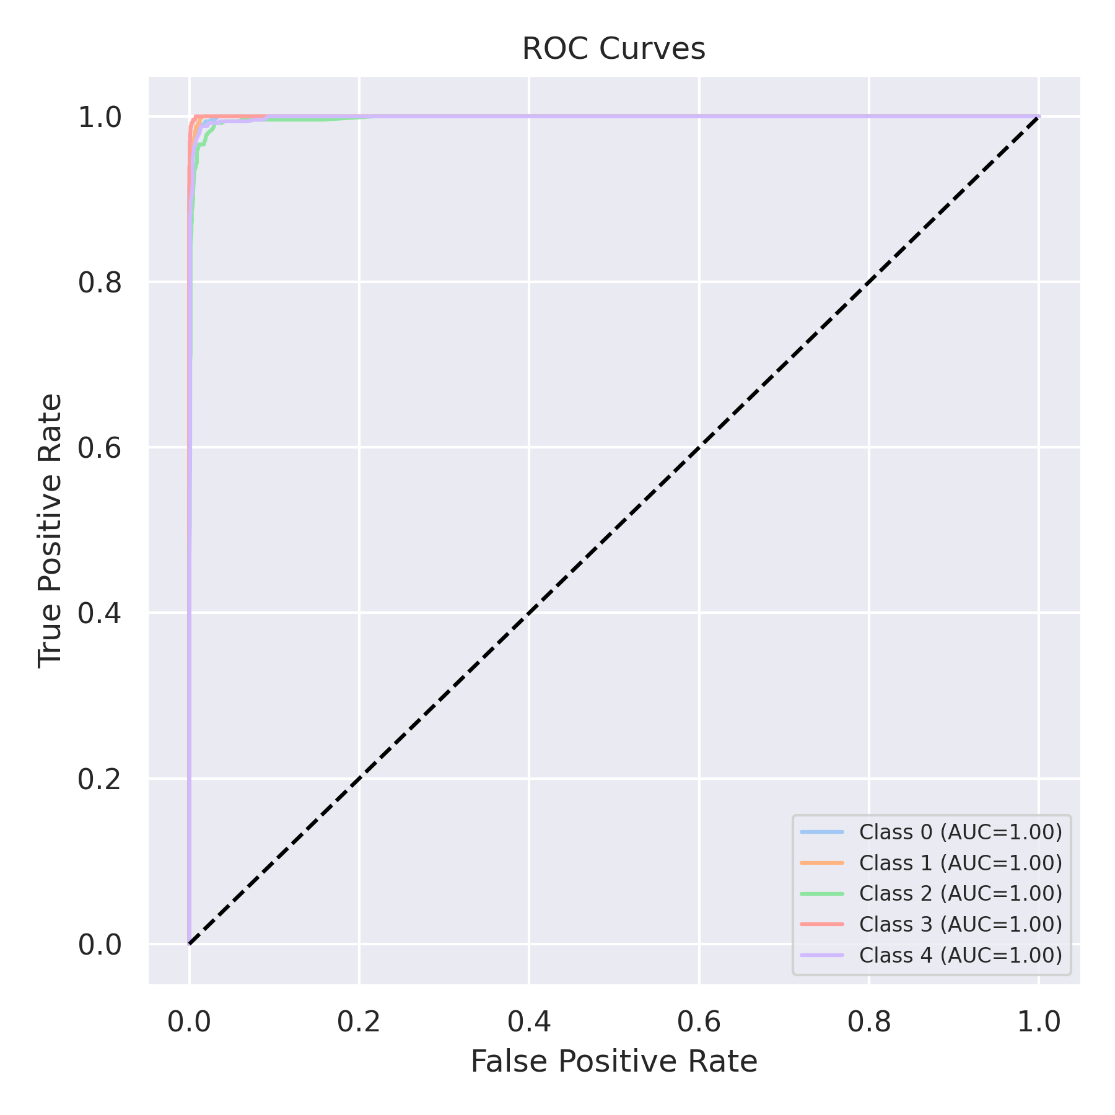

Evaluation: Bagging Classifier
Accuracy: 0.974
Precision: 0.9740297753242907
Recall: 0.974
F1 Score: 0.9739869115627038
Jaccard Index: 0.9495812670689922
Matthews CorrCoef: 0.9675139323009385
Cohen’s Kappa: 0.9675
Specificity: 0.9935
AUC: 0.9971250000000002
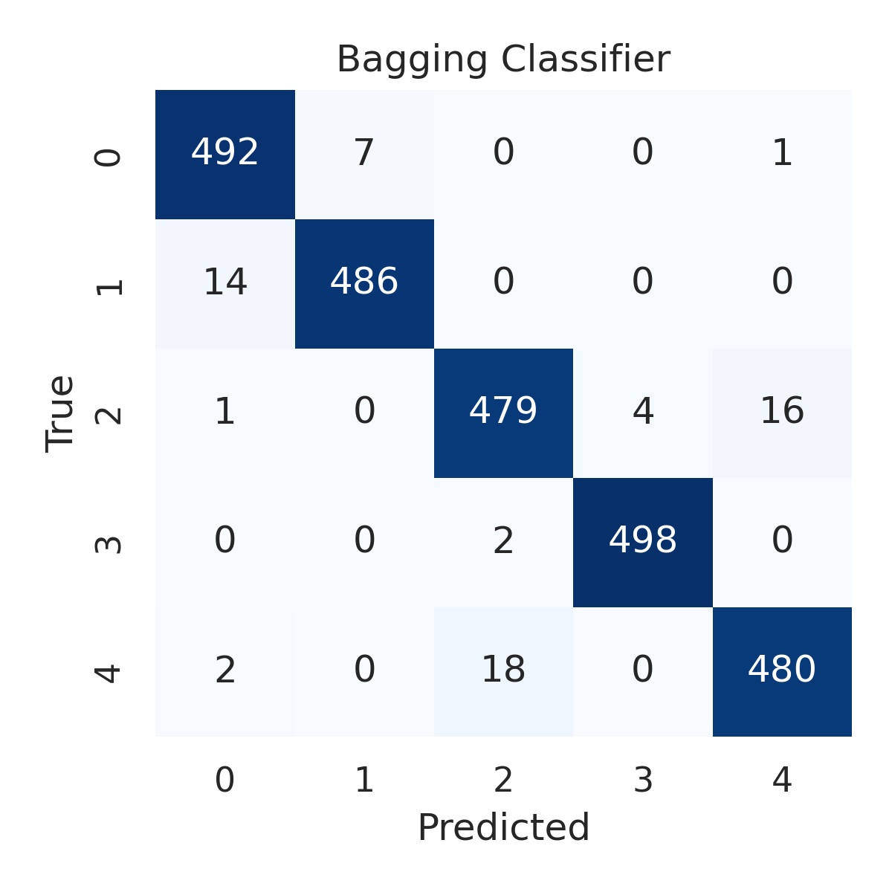

Combined ROC Curves
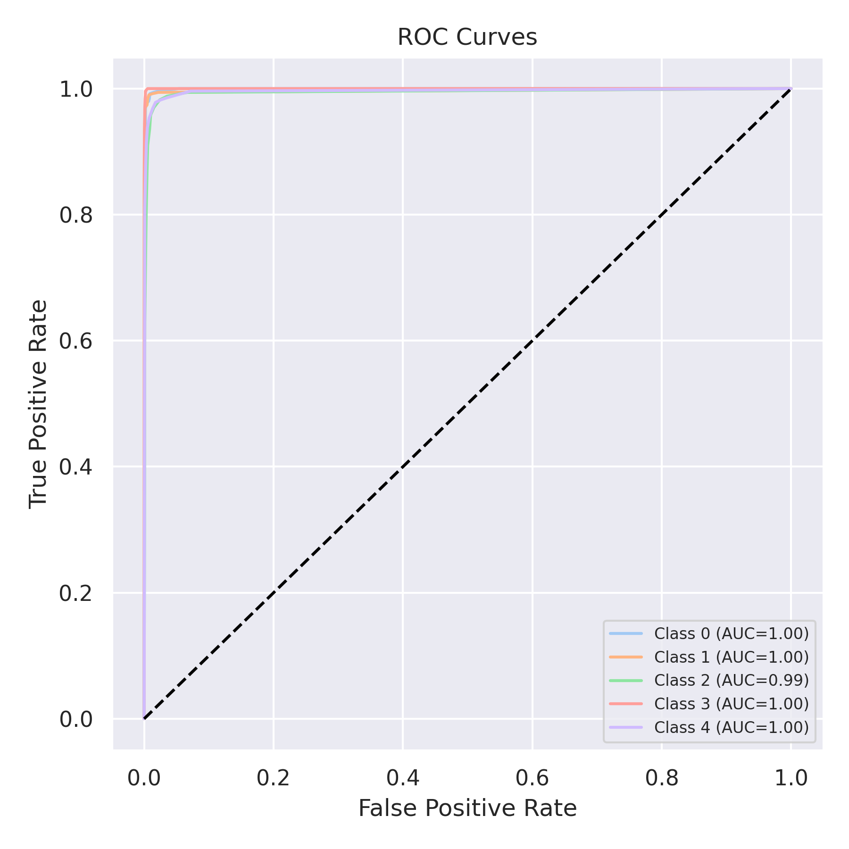

Evaluation: XGBoost
Accuracy: 0.9812
Precision: 0.9811931278625143
Recall: 0.9812
F1 Score: 0.9811898749100543
Jaccard Index: 0.9632402322192837
Matthews CorrCoef: 0.9765033201169325
Cohen’s Kappa: 0.9765
Specificity: 0.9953
AUC: 0.9995376
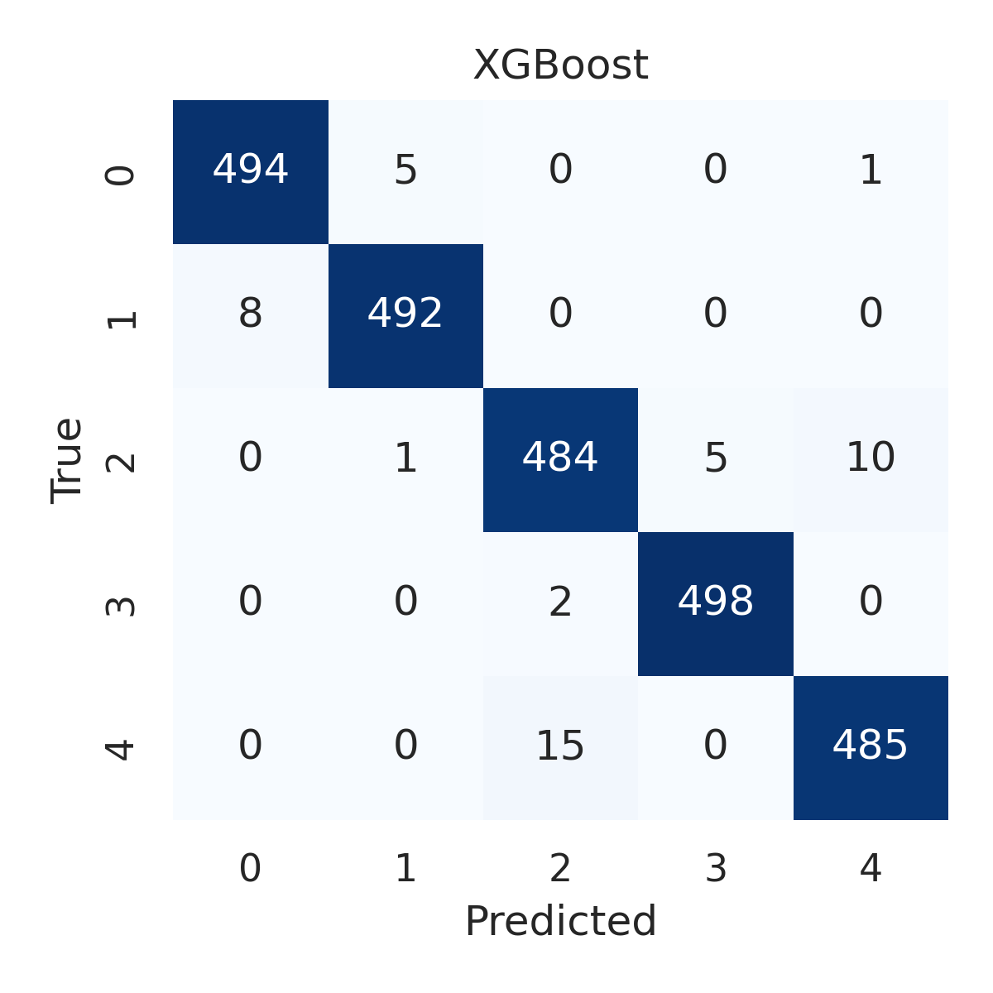

Combined ROC Curves
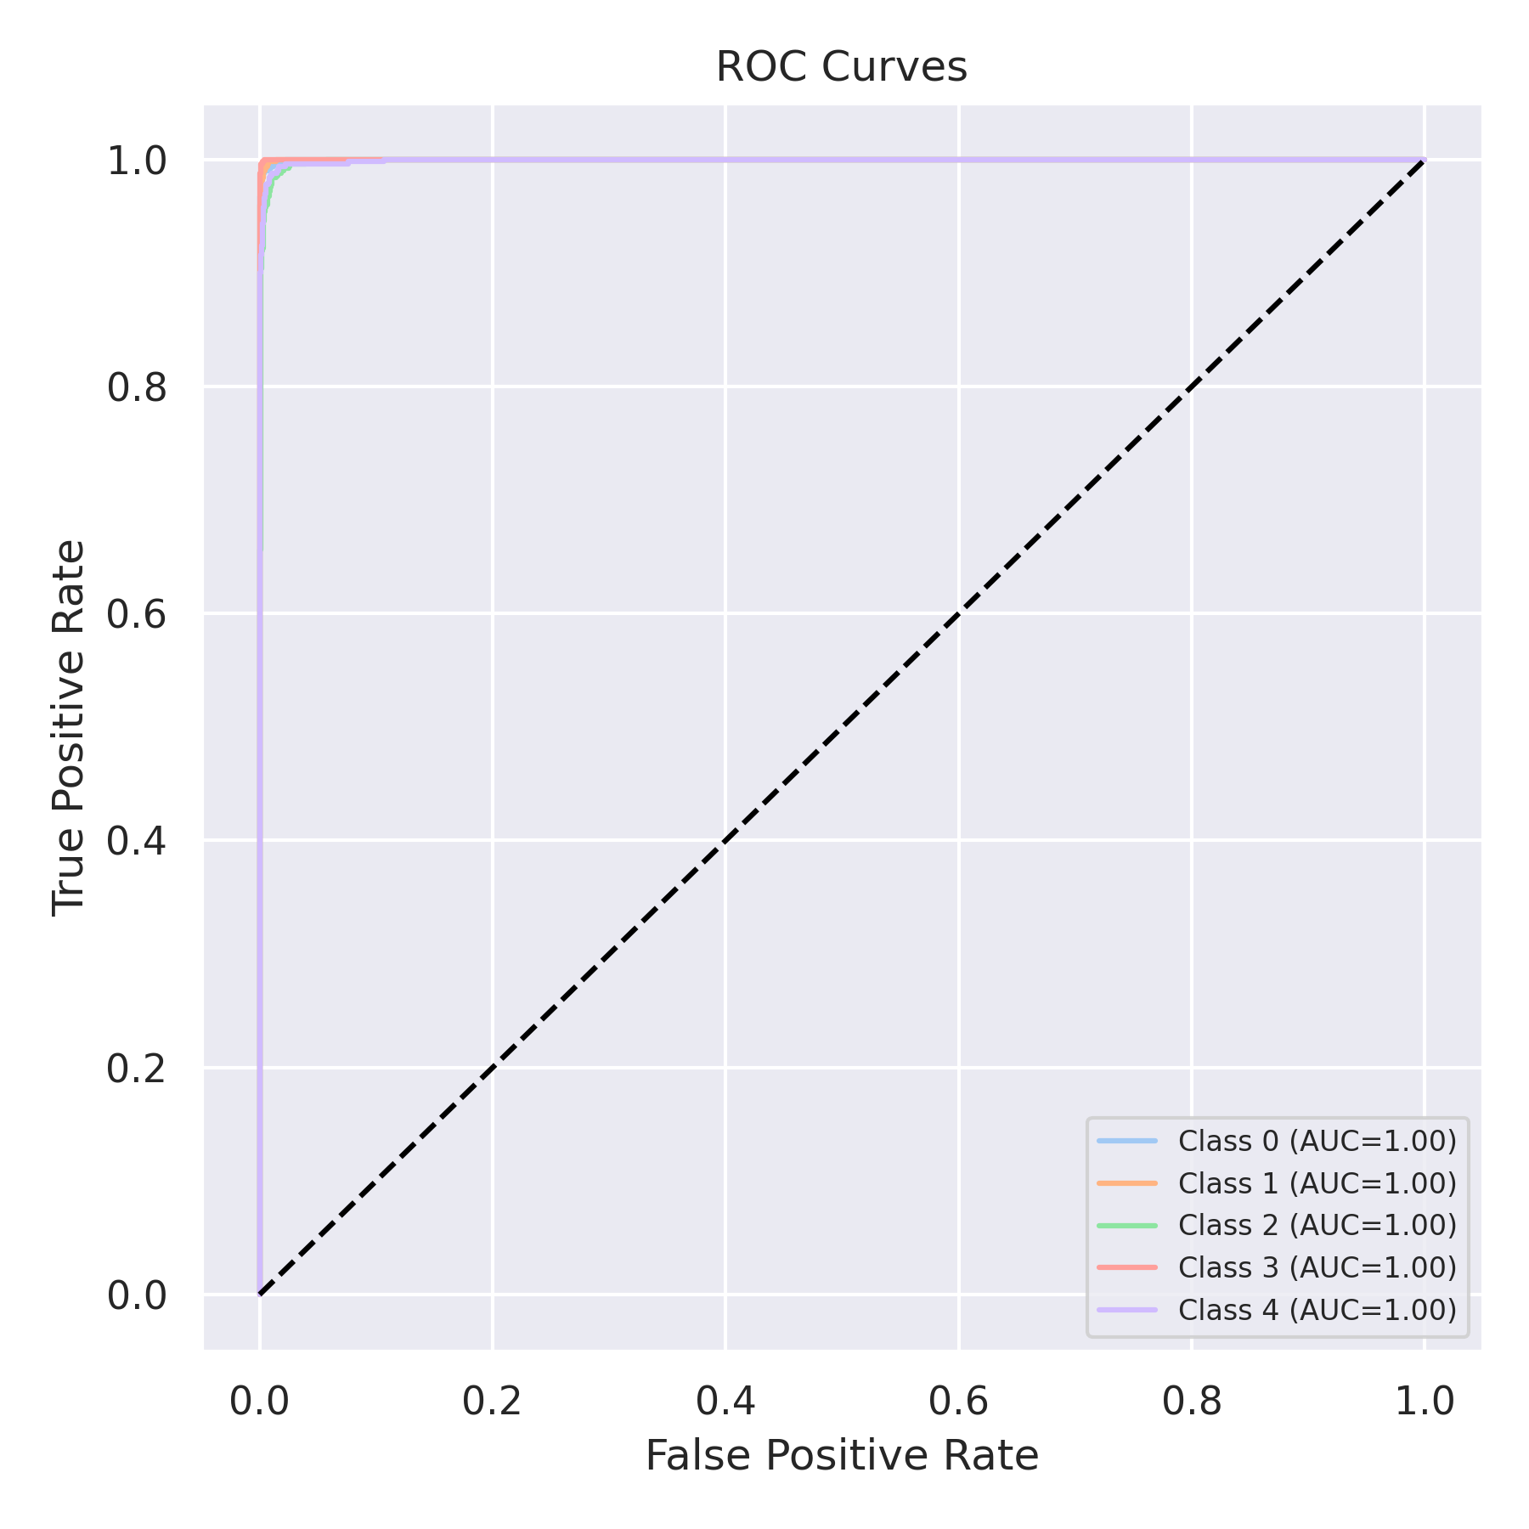

Evaluation: LightGBM
Accuracy: 0.986
Precision: 0.9859942573452434
Recall: 0.986
F1 Score: 0.9859943631582719
Jaccard Index: 0.9724809382264886
Matthews CorrCoef: 0.9825013755028885
Cohen’s Kappa: 0.9825
Specificity: 0.9964999999999999
AUC: 0.9995552
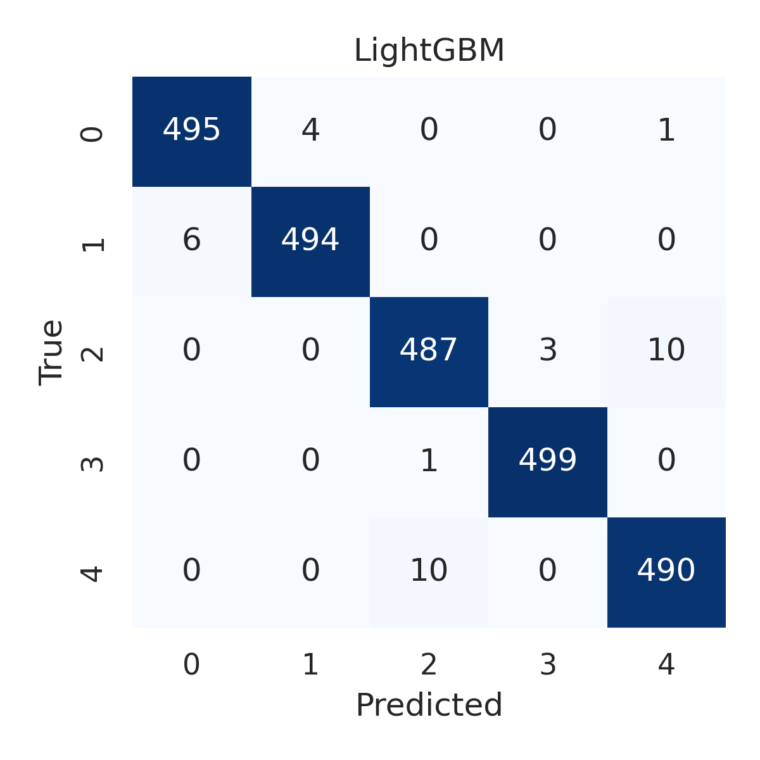

Combined ROC Curves
